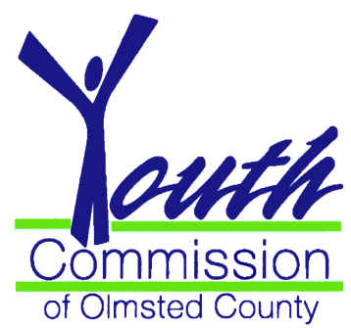

The Rochester/Olmsted Youth Commission
19th Annual “Outstanding Youth Awards”

We invite you to nominate a youth who has gone above and beyond expectations to make a difference in our community by demonstrating:
- Personal growth
- Initiative and community impact
- Leading by example

Winners will be recognized during the April 22, 2014 meeting of the Olmsted County Board of Commissioners at the Government Center in Rochester. It is a special and exciting event, with invitations sent to winners, their families, elected officials and the press. Each winner will be presented with an award followed by a reception in the Government Center Rotunda.

Eligibility Requirements:

- Nominees must be between the ages of 13 and 20 and reside or attend school in Olmsted County
- Nominators may be youth or adults who know of a special person
- Nomination deadline is Friday, March 21, 2014. Return Nominations to the Youth Commission via:
- Mary Gorfine, Olmsted County Administration, 151 SE 4th Street, Rochester, MN 55904
- Email: gorfine.mary@co.olmsted.mn.us
- Fax : (507) 328-7967

Take just a few moments now to let our youth know how much they are admired and appreciated by completing the attached nomination form.

Questions? Please contact Mary Gorfine, 328-6005 - Or by e-mail gorfine.mary@co.olmsted.mn.us

Nomination Form

Nominees must be age 12 – 20 and attend school or reside in Olmsted County. Persons of any age can be a nominator. Please provide the information requested, and answer the question at the bottom of this page on a separate sheet of paper.

The deadline for receiving entries is: Friday, March 21, 2014.

Return this completed form to: Olmsted County Youth Commission
Olmsted County Administration
151 SE 4th Street
Fax: (507) 328-7969

Email: Gorfine.mary@co.olmsted.mn.us

Phone: 507-328-6005

Nominee Information:

Name _________________________________________________________ Age________________

Complete Mailing
Address________________________________________________________Zip_________________

Phone _________________________________ School _________________________ Grade ______

Nominator Information:

Name _________________________________________________ Day Phone _________________

Email ______________

Relationship to Nominee_____________________________________________________________

Describe why you believe this young person should be recognized as one of the 5 most outstanding youth in Olmsted County. Whenever possible, use specific examples to illustrate how this young person has demonstrated personal growth, leading by example, initiative, and the impact on our community that has resulted from their actions. Feel free to include any information regarding obstacles or challenges that she or he may have overcome, and personal characteristics that exemplify their character, and commitment to making a difference in their community.

