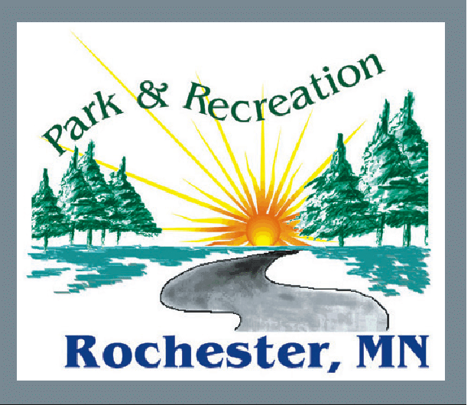
ROCHESTER PARK AND RECREATION
DEPARTMENT

POLICY ON NEIGHBORHOOD GARDENS LOCATED IN CITY PARKS

PURPOSE
To establish a policy and procedures to administer requests for vegetable or flower gardens on park land and/or public lands under the stewardship of the Rochester Park Department.

HISTORY
The current park land encroachment policy does not allow gardens on park land. The Board has requested a change to this policy whereby recognized neighborhood associations and / or representatives acting on behalf of the Rochester Area Foundation (RAF) can submit requests to collectively garden on park land or on isolated public owned lots under the maintenance stewardship of the Park Department. Applicants will be required to pay for the exclusive use of these permitted garden areas. The Park Board will establish the fee on an annual basis. No fees will be required for 2011 permitted garden sites.

The properties where gardening will be permitted via permits issued by staff will be vacant lots, remnant ROW , properties acquired by the City via tax forfeiture, gift or acquired by the City for future use that are not immediately adjacent to recognized parks and are isolated parcels separate from larger recognized park parcels

Applications for gardening in park areas to be approved by Park Board.

POLICY ADMINISTRATION
- Administration of the policy to be by Director of Parks or designee
- Requests for use of lots for gardening to be made annually by a representative of the recognized neighborhood association or RAF CROPS program. Assignment of neighborhood association gardens is limited to members of the association living in the neighborhood. Assignment of RAF CROPS gardens is limited to the public living in the general vicinity of the garden site. The applicant shall be considered the point of contact for the activity for that year and shall be responsible for assigning spaces to the neighbors interested in gardening and shall be responsible for resolving disputes concerning the assignment of garden spaces.
- Specific areas to be gardened shall be indicated on the application
- A 20’ buffer to adjacent properties be maintained
- Applicant may install signage, maximum size 1’X2’, at immediate entrance to gardens
- Gardens to be kept neat and orderly and relatively free of weeds. Tools, hoses, compost piles etc are to be stored within the approved gardening area.
- Applicant to arrange site preparation each season and arrange the cleaning of the
site at end of season. Applicant to arrange for GOPHER 1 CALL utility location before preparing the site.
- No yard waste, including grass clippings, to be brought to the site
- No storage or water holding structures or compost bins higher than 3’ shall be allowed.
- Gardening season shall be considered 1 April – 15 October. The permission to utilize the property for gardens shall expire at the end of each season.
- Applicant to be responsible for disposal of trash, garden waste and rubble accumulated while performing gardening operations. Disposal of rubble and yard waste in adjacent park department refuse containers is not allowed.
- Applicant to perform routine turf maintenance on the rest of the vacant lots or remnant
parcels that is not being cultivated for gardens.
- No existing trees / shrubs located on the parcel shall be removed without department
approval.
- Applicant to be responsible to restore the property to turf when permission to garden is no
longer granted or the applicant wishes to discontinue gardening the property.
- Vehicle access to garden sites and parking limited to public streets, park drives or parking
lots
- Applicants and gardeners are expected to observe existing general park rules and
regulations in addition to above stated policy guidelines.

06 APRIL 2011

