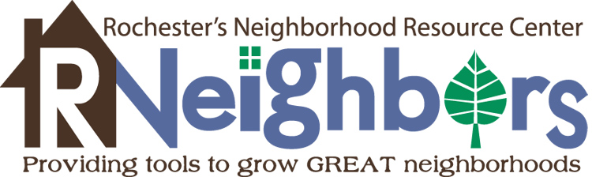
2015
Neighborhood Grant Final Report

Please fill out this form so that we know useful facts to share about the success of your project. Not only will this help us spread the news about the good work your neighborhood is doing but will help us in future years to secure the funding to continue this program.

- Project title:

- Neighborhood association name:

- How has this project benefited the neighborhood? Is there a stronger sense of community? Why?

- How were neighbors engaged in the planning and implementation of this project?

- How many volunteer hours were used to plan and implement this project (estimated)? What were the tasks neighbors helped with?

- We made it through the first year of this program! How could this grant process be improved in the future?

- Please provide a detailed budget of expenses, in-kind donations/discounts, etc.
Item | Source | In-Kind Amount | Cash Amount
Total Funds Requested

Total in Match

(add rows as needed)

- Please email photos of this project that may be used for RNeighbors marketing.

- Name/signature of persons submitting the report:

_____________________ _____________________
(print name) (email)

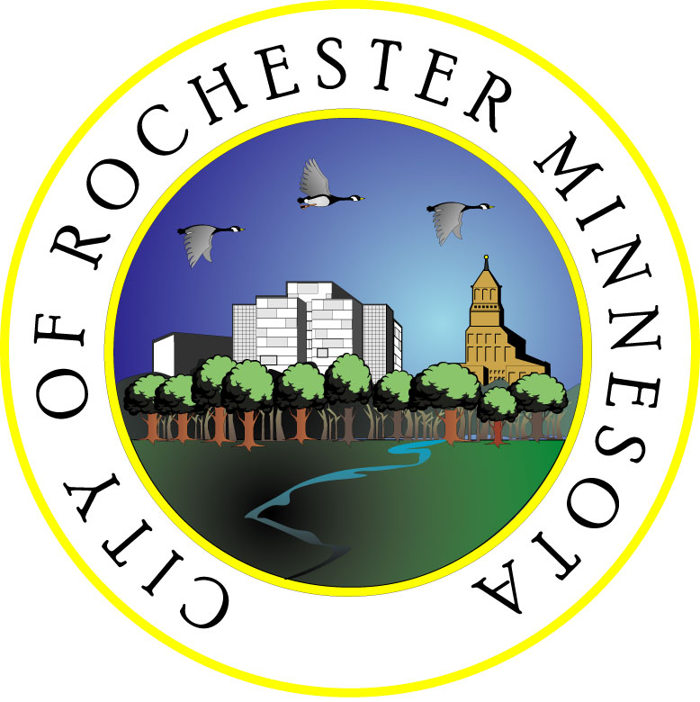
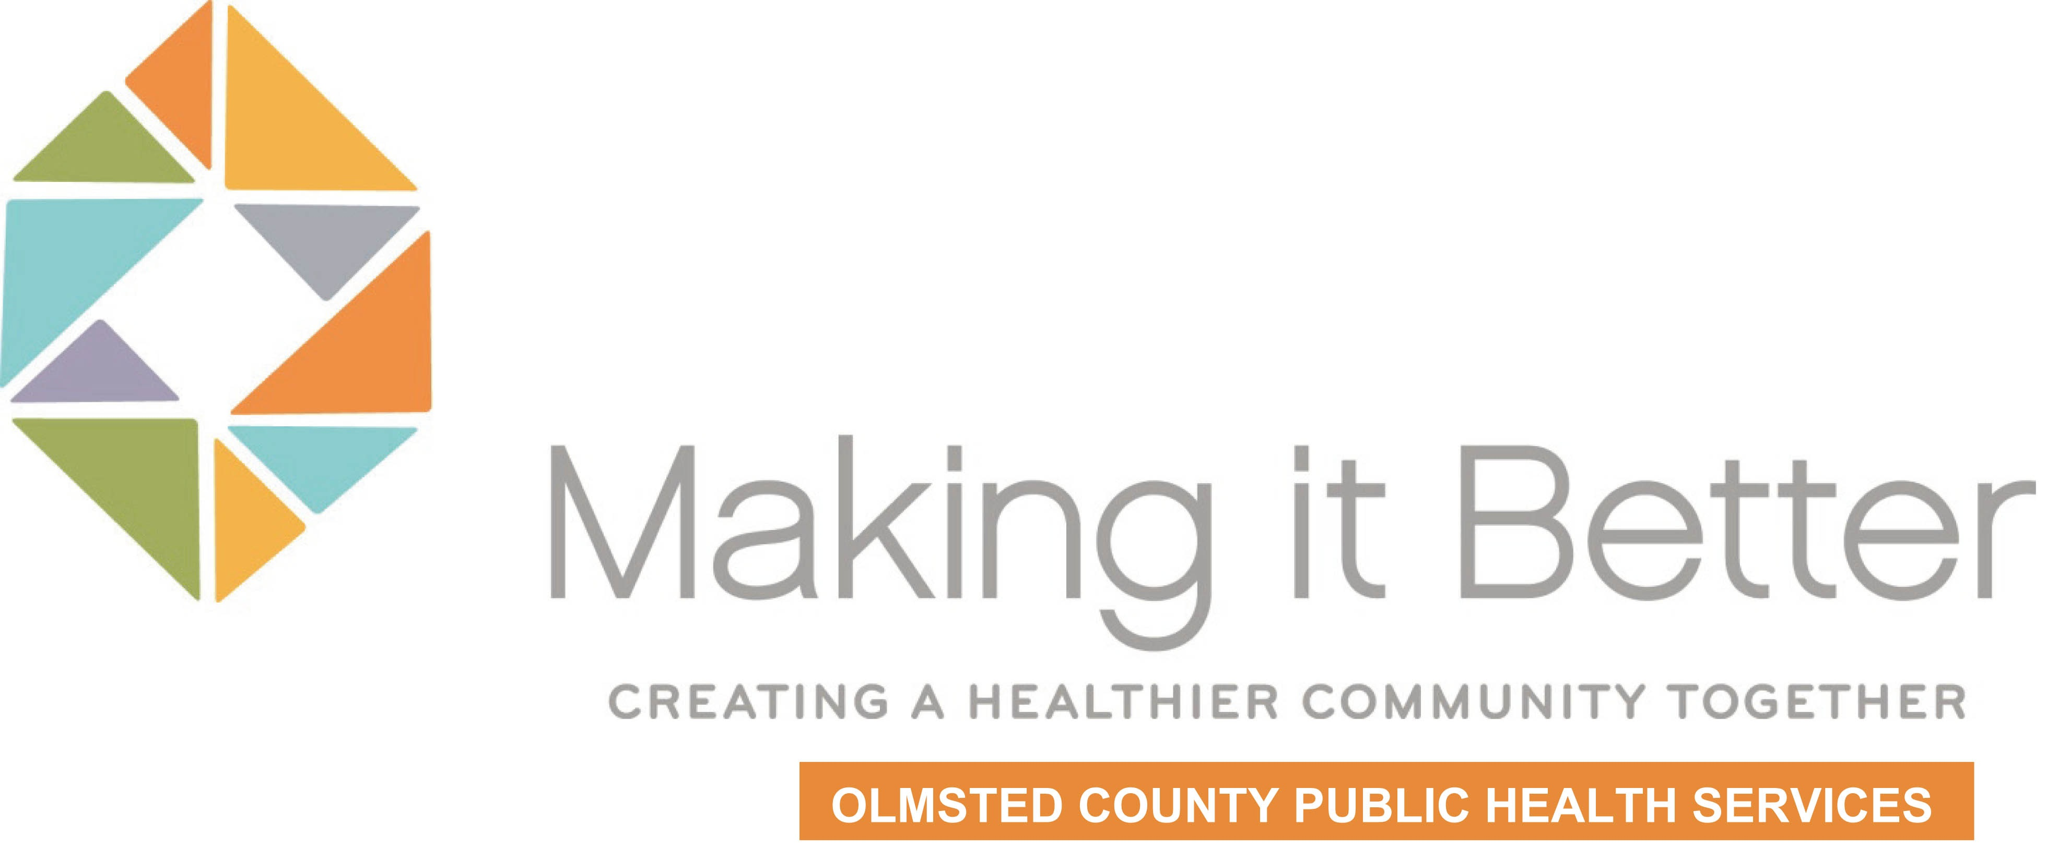
- Please submit the Neighborhood Grant Final Report by 5 pm on Monday, November 30, 2015, to rene@RNeighbors.org. Questions – contact René Lafflam, rene@RNeighbors.org.
Project
Partners

