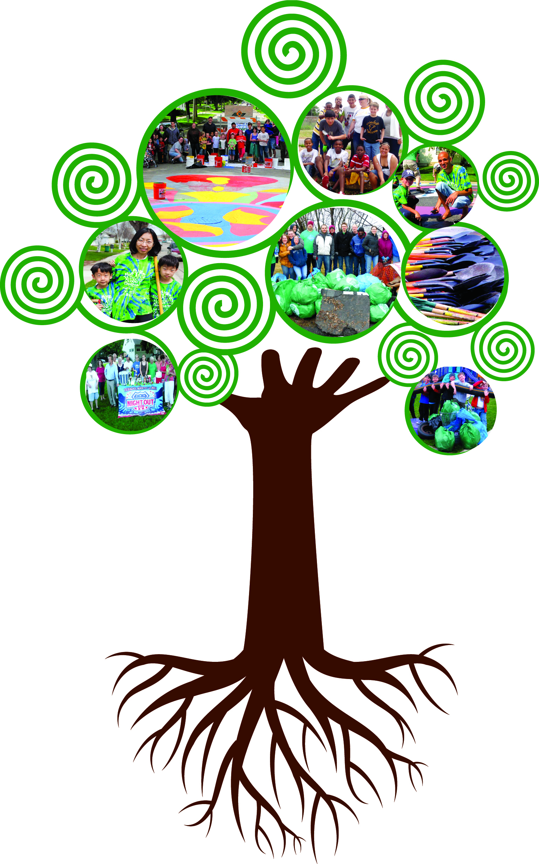

Cultivating
Capacity in
Rochester Neighborhoods
2018

Neighborhood

Project Grants

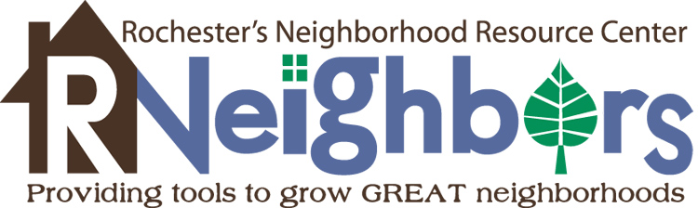

125 Elton Hills Drive, Room 240 ● Rochester, MN 55901 ● 507.529.4150 ● www.RNeighbors.org

Project
Partners

2018
Neighborhood Project
Grant Overview

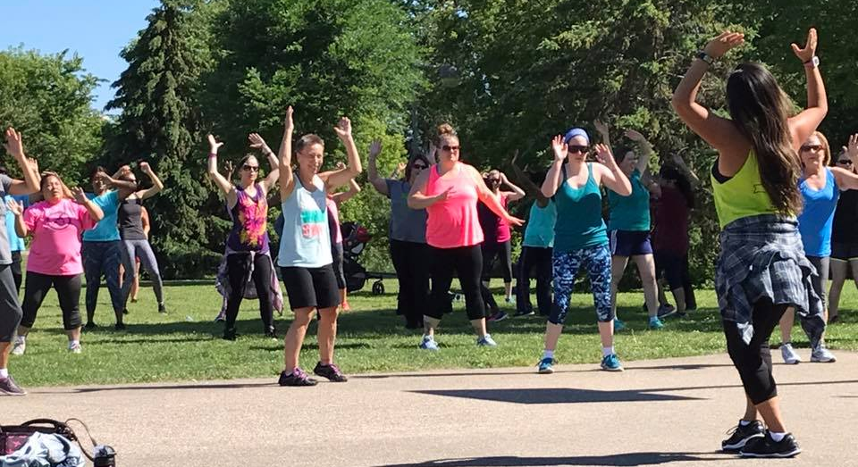
What is the Neighborhood Project Grant?
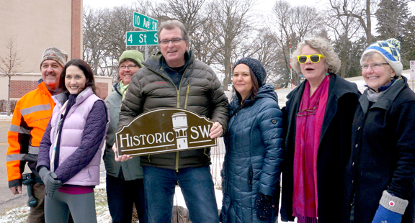
These grants reimburse up to $1,000 in costs for neighborhoods to complete projects that enhance a neighborhood’s livability and involvement, benefit the entire neighborhood and promote a strong sense of community. We encourage you to be creative. These non-revenue producing projects can include, but are not limited to, identification signage, mini libraries or food pantries, pocket park improvements, physical activity opportunities, butterfly & rain gardens, native plantscaping and public art projects.

Are you specifically interested in a community food garden?
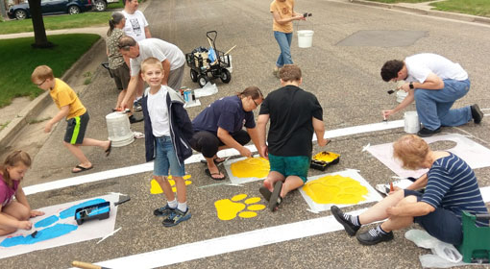
Allowable expenses include start-up gardening supplies (such as shovels, rakes, hoses, seeds, starter plants, and dirt), materials to construct raised bed gardens, signage, fencing, and garden watering equipment. Unallowable expenses include large sheds, underground irrigation systems, land rentals for gardens, liability insurance, labor to install garden, goods or services for personal use, or other costs incurred prior to grant award.

Total Neighborhood Project Grant Funding Amounts
- $8,000 for general neighborhood grants (including community food gardens)

Eligible Applicants
- Individuals and community groups must work with their registered neighborhood association to apply for grants.
- A complete list of existing registered neighborhood associations is available online.
- Creating a Neighborhood Association in Rochester is FREE. For more information on establishing an association in your neighborhood, or questions related to the grant application process, contact René Halasy, RNeighbors’ Executive Director, at: rene@RNeighbors.org.
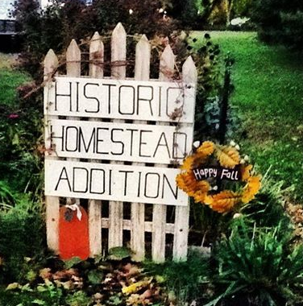
General Requirements (continued on page 3)
- Successful projects will focus on improving a neighborhood’s community involvement and livability.
- A final report MUST be completed at the end of the grant cycle or the Neighborhood Association will be ineligible for grant funds the following year. The final report question will be provided upon notification of successful grant award to ensure data tracking is easy and accessible from the start of the project. This information is imperative to continue receiving funds for the grants to be available in the Rochester Community.
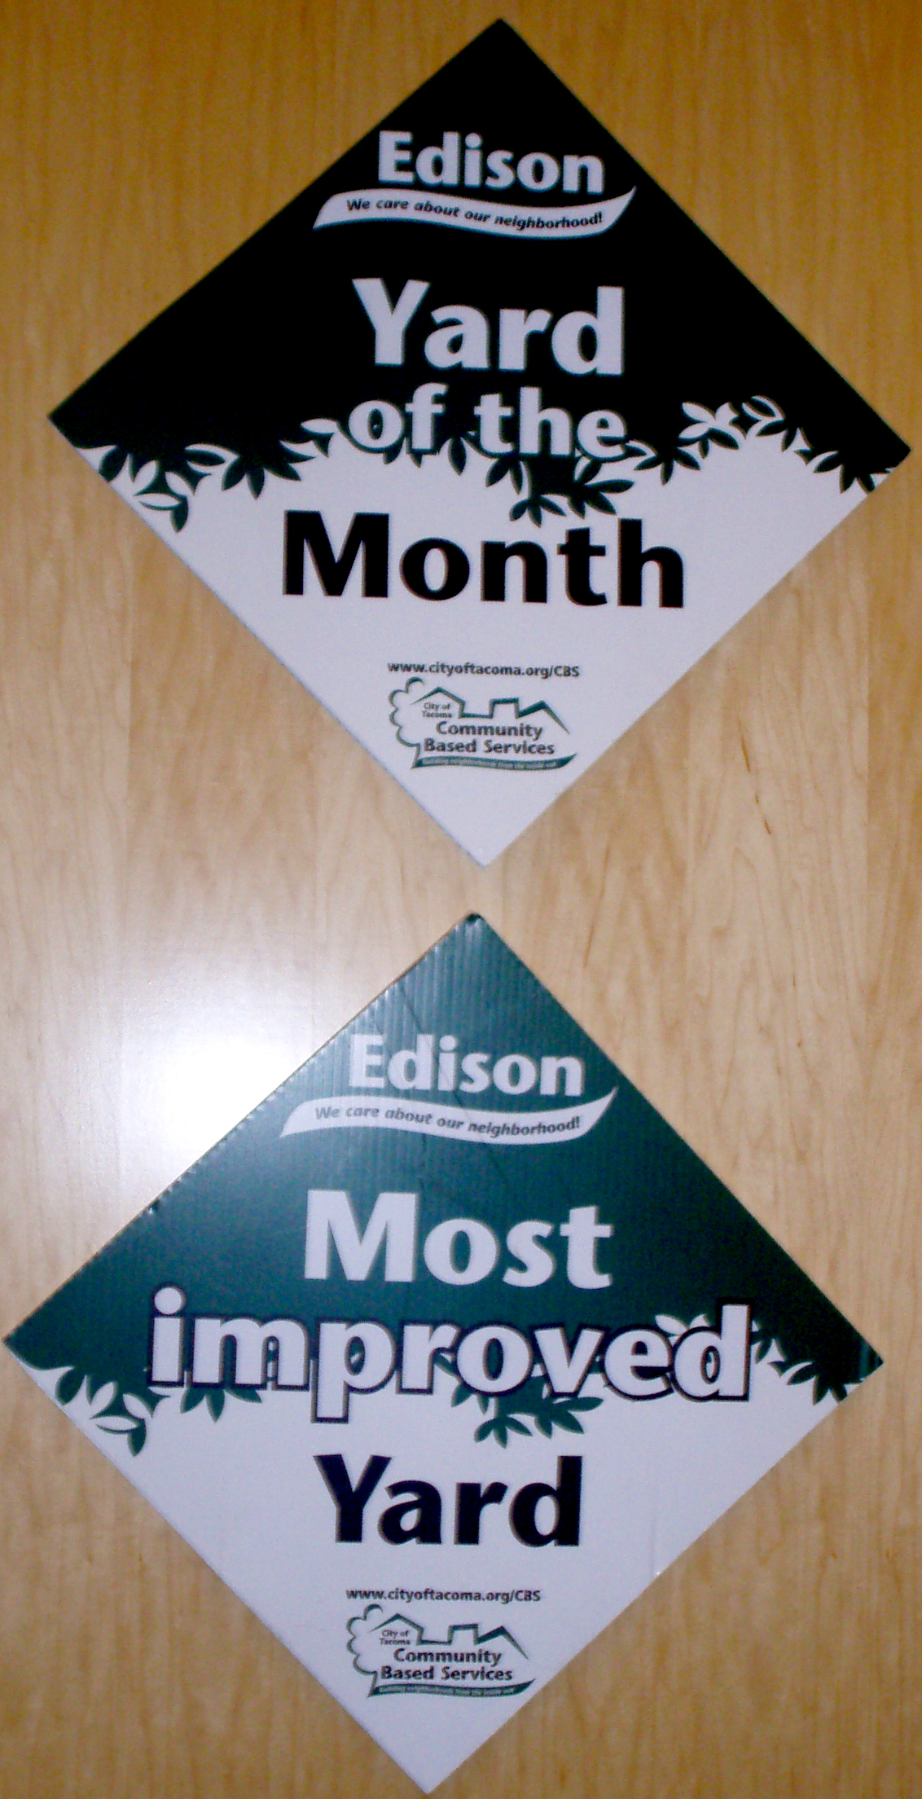
- Neighborhood associations are limited to one grant application per registered association up to $1,000. However, the grant application may encompass many projects in one application. For example, a neighborhood could request $500 for a community garden, $100 for a mini library, and $400 for a unique social event. The project oversight should be directed by the elected Neighborhood Association leaders with designated project leads to ensure cohesion amongst various projects. A realistic budget of all expenses for the project must be included with the application.
- Projects with matching funds and/or in-kind labor (e.g., volunteer time, donated supplies, discounted materials, etc.) will be given greater consideration for grant funding. Examples of eligible match include volunteer labor, donations of equipment, materials or a monetary match from neighborhood association members or donors.
- Allowable expenses include (but are not limited to) project materials, rental equipment costs, specialized labor (arborist, heavy equipment operator, muralist, etc.), landfill fees, cleanup supplies (paint, gloves, garbage bags, etc.) and delivery charges.
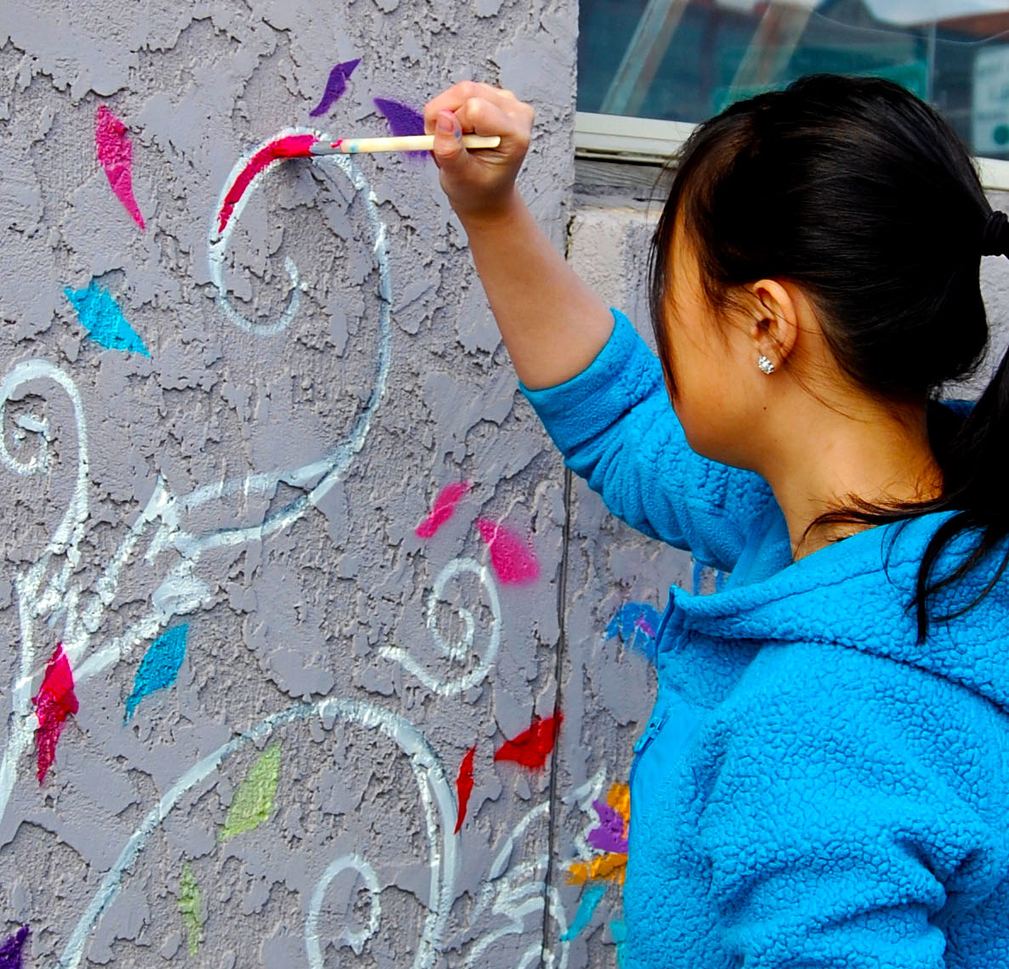
- Unallowable expenses include grant writing, routine maintenance, ongoing operating expenses, advertising and promotion, sponsorship of ongoing program efforts through another entity (e.g., Police Department’s neighborhood dog walker watch program), unspecialized labor costs, yard equipment (exception for community food garden grants), food and beverages, facility rental, after-event parties, or any expenditure deemed to be inconsistent with the grant program purpose or not allowed by law or ordinance.
- All projects must adhere to the City of Rochester’s ordinance and approval processes.
- Applicants are required to work with registered neighborhood associations. While project leads are not required to be on their Neighborhood Board, there should be frequent communication between project leads and Neighborhood Boards to ensure project is successfully completed in the manner in which is was proposed.
- Incomplete applications will not be considered. RNeighbors staff and board members are available to assist with questions or concerns regarding completion of the application.
- Project photos taken or submitted may be used by RNeighbors on the website and/or social media.

Neighborhood Project Grants Timeline
Application Deadline: Wednesday, March 14, 2018, at 5 pm
    - All applications must be submitted to RNeighbors via email at rene@RNeighbors.org.
    - Applicants must complete an application and attach necessary supporting documentation. Please read all of the instructions carefully before filling out the application. It is extremely important to fill out the application form properly. If in doubt, ask questions.
    - If your request is approved, you must adhere to your application and the Neighborhood Project Grant Agreement throughout the grant’s duration. This includes the project scope, budget worksheet and submitting a final report by the deadline.
    - Again this year we’ll be highlighting some neighborhoods awarded a grant in a video presentation. Scheduling a time to work with RNeighbors and the videographer may be necessary so we can tell your project’s success story.

Project Evaluation and Selection
The Neighborhood Project Grant selection team will review the submittals based on their merits and then make a recommendation to the RNeighbors Board of Directors for final decisions. Keep in mind that Neighborhood Project Grants are competitive, and the number and size of awards are limited by the amount of available funding.

Applications will be reviewed and selected based on the project’s ability to reflect the following objectives.
- Empower citizen leaders
- Foster a vibrant, healthy and livable community
- Nurture citizen involvement for positive change

Notification of Awards: Friday, April 6, 2018
The 2018 grant winners will be posted publicly at RNeighbors.org. All applicants will be notified via email communicating their grant status.

Project Completion Deadline: Tuesday, October 30, 2018

Need More Information?
Contact René Lafflam at rene@RNeighbors.org or visit http://www.RNeighbors.org/.

Additional Community Grants (available separate from the Neighborhood Project Grants)
- Rain Garden Grants
Do you want to reduce stormwater runoff, improve water quality, and provide habitat by installing a rain garden? Rochester residents and non-profits are eligible to apply for a cost-share grant to help install a rain garden on their property. Grant awards will match 50% of eligible costs up to a maximum of $750! Learn more at www.rochesterstormwater.com/rrr.
- RNeighborWoods Tree Grant
Twice a year, in the spring and the fall, RNeighbors, the City of Rochester and RPU offer a grant for a winning neighborhood to receive 25 free boulevard trees. In addition to helping plant the trees, neighborhoods need to work with their neighbors to determine appropriate tree locations with final approval from City Forestry. www.RNeighbors.org

RNeighbors 2018 Neighborhood Grant Application Form
- This application is for the:

Neighborhood Project Grant
Community Food Garden Grant

- Neighborhood association name:

- Neighborhood association board members:

________________________________ ________________________________

________________________________ ________________________________

________________________________ ________________________________

- Core leadership team on the project:
Name | Phone | Email
(add rows as needed)

- Project Narrative
5.1. Project title: ________________________________

5.2. Brief project description:

  - Detailed budget (include in-kind donations):
In-Kind includes: donated supplies, reduce rates, or volunteer time at a value of $24.14 per hour. Please provide a financial amount.
Example: Donated Supplies $450 and Volunteer time (70 hours x 24.14) $1,689.90 total of $2,139.80

Item | Source | In-Kind Amount | Cash Amount
Total Funds Requested

Total in Match

(add rows as needed)

5.4. Address the following questions in 500 words or less:
- Describe how this project will enhance/benefit the neighborhood and foster a sense of community?
- How does the project include opportunities to involve multiple neighbors in shaping and carrying out the project?
- How have neighborhood residents been included in the project planning process?
- List matching funds or in-kind labor (e.g., volunteer time, donated supplies, discounted materials, etc.) that will be contributed to the project.
- What partners are supporting and/or collaborating on this effort?

- Attach the following:

- Letters of support and/or assistance from Neighborhood Association President and any in-kind participants.
- Project location map (8½” X 11”).
- A site design, if applicable (8½” X 11”).
- Proposed project/site photos (digital copies are preferred and can be attached to the application or emailed to rene@RNeighbors.org with project title as the subject).

- Name/signature of persons submitting the application:
If awarded, the total scope of work and implementation of the project are under the domain and control of the neighborhood association. The City may exercise oversight of the project if related to City-owned facilities or for large projects. We certify that the decision-making body of the applying group has discussed this information, and all information contained herein is accurate.

_____________________ _____________________ _____________________
(print name) (signature) (email)

_____________________ _____________________ _____________________
(print name) (signature) (email)

_____________________ _____________________ _____________________
(print name) (signature) (email)

Please submit the completed application by Wednesday, March 15, 2018, at 5 pm, to rene@RNeighbors.org.
Questions – contact René Lafflam, rene@RNeighbors.org.

