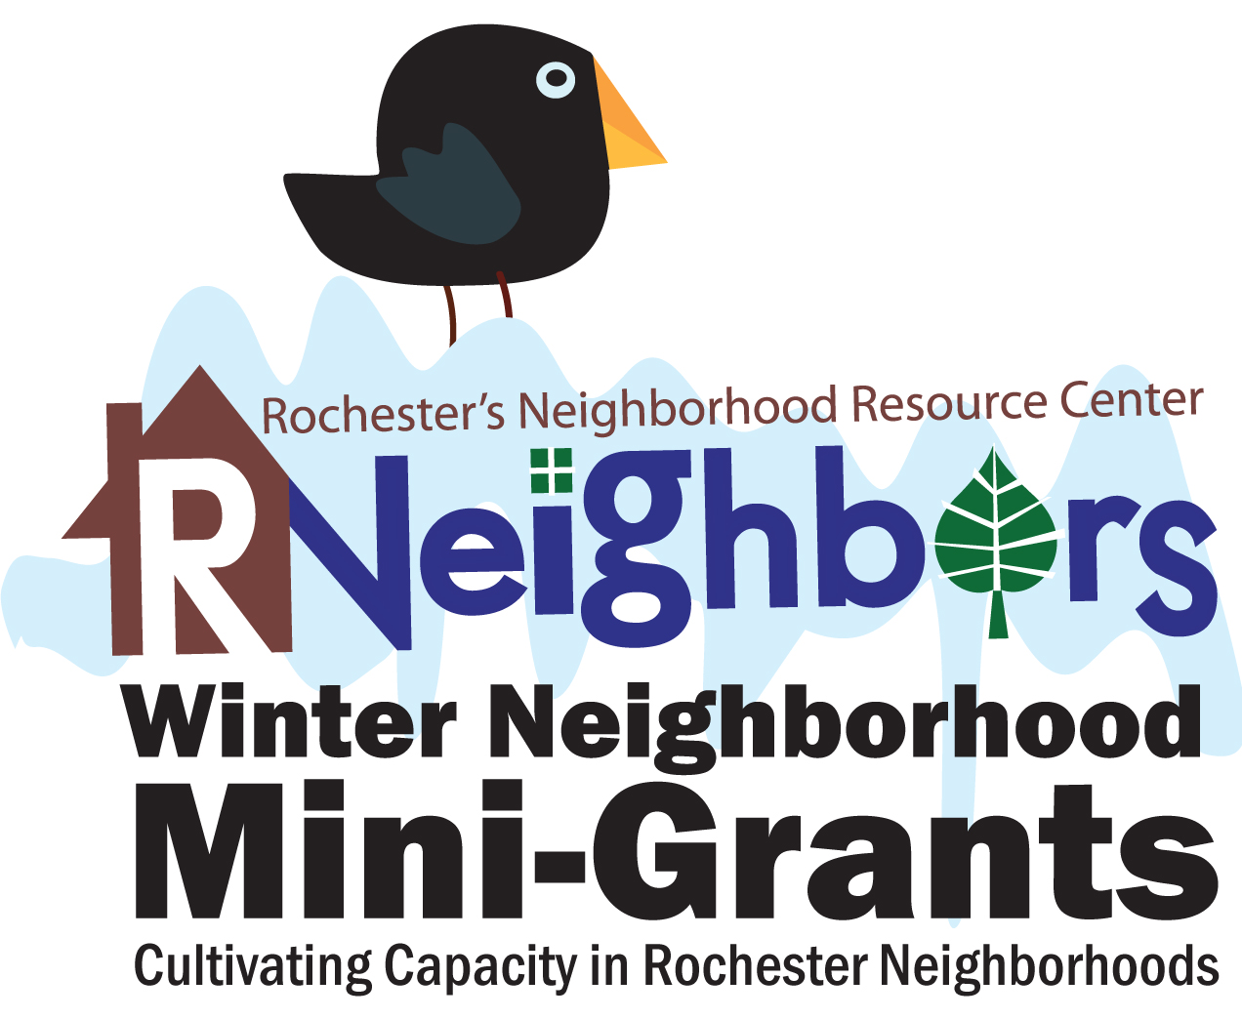
2020 Mini-Grant Application Form

The RNeighbors Winter Neighborhood Mini-Grants will reimburse up to $200 in costs to throw a winter activity such as a snowman building contest, sledding party, or garage chili cook-off.

Guidelines
- Only one grant application per neighborhood.
- Maximum grant is $200. Please apply for the approximate amount you'll need. If we have extra funds we can award grants to more neighborhoods.
- Allowable expenses include (but are not limited to) food, craft supplies, outdoor winter equipment such as sleds.
- Unallowable expenses include alcohol or any expenditure deemed to be inconsistent with the grant program purpose or not allowed by law or ordinance.
- All events must adhere to the City of Rochester’s ordinance and approval processes.
- The project must be completed and a short grant summary will be required with expense receipts for reimbursement by March 15, 2020.
- Eligible applicants include neighborhood associations. An unregistered group can submit a “letter of commitment” to form a neighborhood association by the end of the grant period in March.
  - A complete list of registered neighborhood associations is online.
  - Creating a Neighborhood Association in Rochester is FREE. For neighborhood registration, or grant application questions, email René Halasy, RNeighbors’ Executive Director.

- Activity title (Snowman contest, sledding party, Cider share, etc.):

- Neighborhood association:

- Activity description. How will this event enhance/benefit the neighborhood and foster a sense of community?

- Amount requested (up to $200): ___________
Keep your receipts. Expenses are on a reimbursement basis.

- Funds will be used for:

- Names and contact information of persons submitting the application:
If awarded, the total scope of work and implementation of the activity are under the domain and control of the neighborhood association. We certify that the decision-making body of the applying group has discussed this information, and information contained herein is accurate.

_____________________ _____________________ _____________________
(print name) (cell number) (email)

_____________________ _____________________ _____________________
(print name) (cell number) (email)

Please submit the completed application by Monday, February 10, 2020, at 5 pm, to rene@RNeighbors.org.
Questions? Contact René Halasy, rene@RNeighbors.org.

