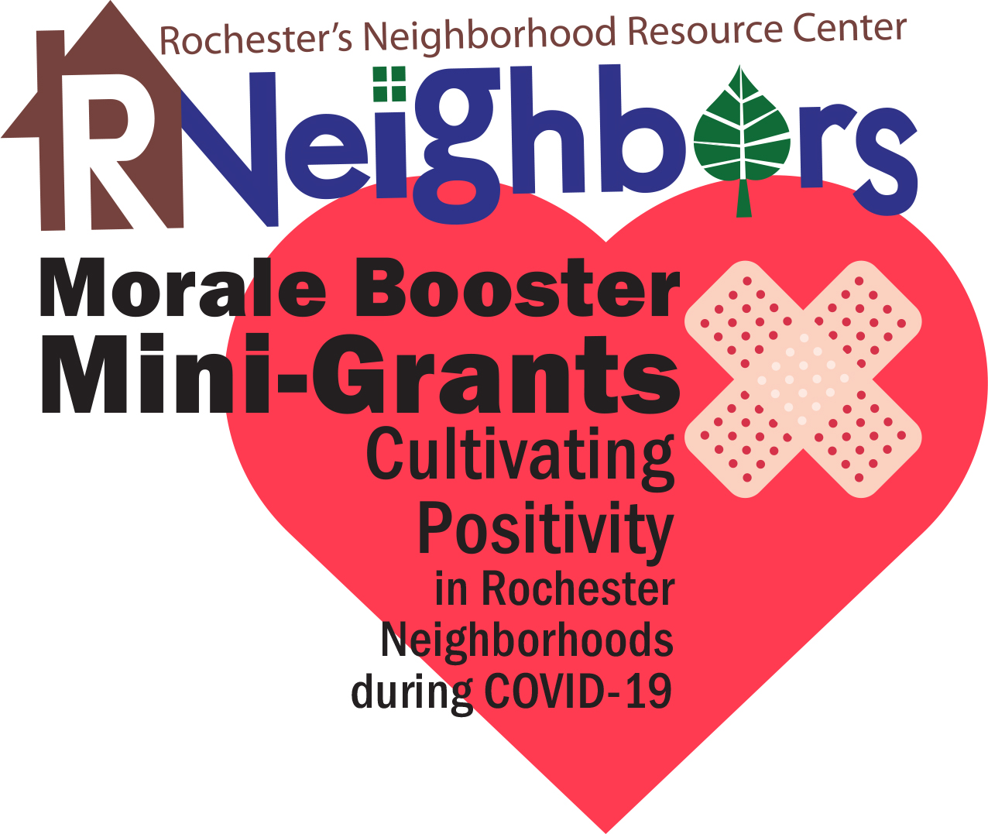
Morale Booster Mini-Grant Application

As we all self-isolate for everyone’s safety, now more than ever it is important to reimagine neighborhood activities, bring joy and positivity in this uncertain time. This mini-grant is an opportunity to utilize and highlight the fun and talents of all ages in your neighborhood.

Grant Guidelines
- Grants reimburse up to $200 in costs to support an activity that will help the neighborhood community weather this pandemic.
- All neighborhoods are eligible, does not need to be a part of a registered neighborhood association.
- We encourage you to collaborate with a local artist, musician, or writer, giving work to those who need it. If you need contacts email RNeighbors.
- Proper social distancing is required for grants. Activities must align with Minnesota Department of Health Guidance and Governor Walz Executive Orders.
- Grant Ideas
        - Supplies for signs of encouragement or banners including poster board, sidewalk chalk, markers, fabric, etc.
        - Printing and postage for a cheerful postcard mailing
        - Hiring a local musician or DJ for a neighborhood dance party (everyone dances in their own driveway)
        - Contracting a local artist to work with the neighbors on some sort of public art that could be done with proper social distancing, but enjoyed by all
        - Work with a local designer to produce a neighborhood logo and have t-shirts printed
        - Determine a neighborhood reporter to assemble a weekly newsletter about residents
        - Organize a street-wide or neighborhood-wide contest such as a scavenger hunt or costume parade that the grant could fund flyers and incentives for participation
        - Work on a “playborhood” concept and create an atmosphere for unstructured outdoor play. This article identifies steps that almost any neighborhood can take to promote connections and safe play. https://www.parentmap.com/article/how-to-create-playborhood-play
- Project must be completed by June 30, including a short grant summary with expense receipts for reimbursement.
- Grant applications will be reviewed in 48 hours and applicants will be notified promptly to allow for quick implementation.

We look forward to helping you implement your ideas for cultivating positivity in your neighborhood. Questions? Contact René Halasy, rene@RNeighbors.org.

Please keep in mind at this time many are out of work and in survival mode. If you have neighbors in need of essential supplies, food, or other services please connect them with this community resource for local organizations that can assist. https://c2cmn.com/covid19

Grant Application

- Activity Name (Neighborhood Nightly Band, puzzle share, scavenger hunt, etc.):

- Neighborhood name and location of project:

- Activity description. How will this event enhance/benefit the neighborhood and foster a sense of community?

- Amount requested (up to $200): ___________
Keep your receipts. Expenses are on a reimbursement basis unless requested ahead of time.

- Funds will be used for:

- Names and contact information of persons submitting the application:
If awarded, the total scope of work and implementation of the activity are under the domain and control of the neighborhood. We certify that the decision-making body of the applying group has discussed this information, and information contained herein is accurate.

_____________________ _____________________ _____________________
(print name) (cell number) (email)

_____________________ _____________________ _____________________
(print name) (cell number) (email)

Please submit the completed application by Monday, April 27, 2020, at 5 pm, to rene@RNeighbors.org.

