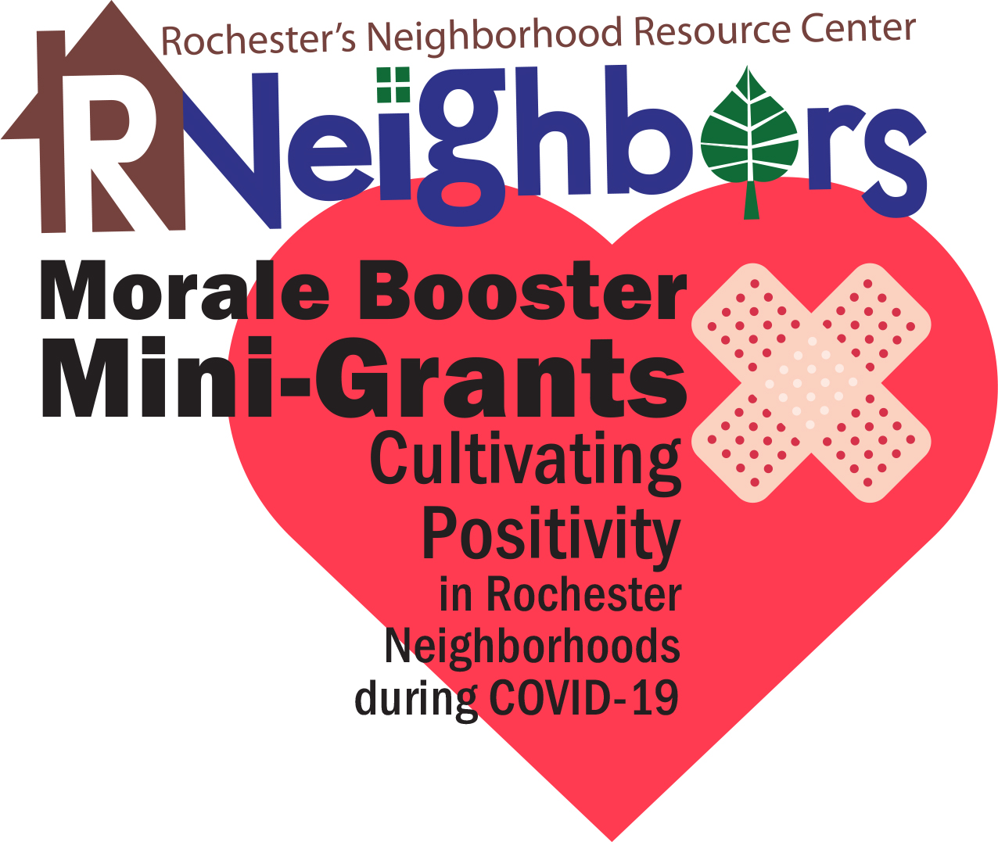
Mini-Grant Final Report

Please fill out this form by June 30, 2020, so that we know useful facts to share about the success of your project. Not only will this help us spread the news about the good work your neighborhood is doing but will help us in future years to secure the funding to continue this program.

- Project title:

- Neighborhood name and project location:

- Tell us about where the idea for the project came from.

- How many neighbors were involved in the final project?

- Estimate number of hours that neighbors helped in success of the project.

- How did this project benefit the neighborhood? Is there a stronger sense of community? Why?

- Please provide a budget of expenses, in-kind donations/discounts, etc.
Item | Source | In-Kind Amount | Cash Amount
Total Funds Requested

Total in Match

(add rows as needed)

- If you haven’t already done so, please email photos of this project that may be used for RNeighbors marketing.

- Name/signature of person submitting the report:

_____________________ _____________________
(print name) (email)

- Please submit the Neighborhood Grant Final Report by 5 pm on June 30, 2019, to rene@RNeighbors.org. Questions – contact René Halasy, rene@RNeighbors.org.

