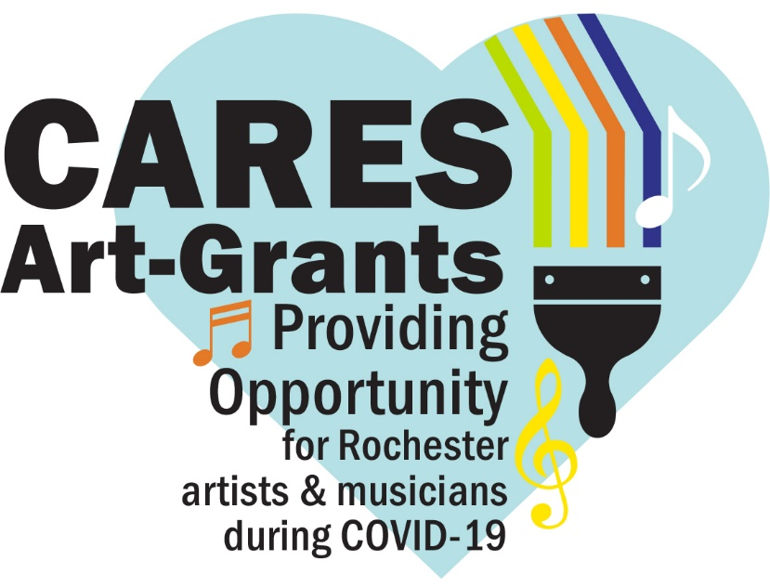
Chalk The Walk
Artist Application Form

On Saturday, August 15, we’re inviting you to take part in a city-wide Chalk the Walk Festival. This will include pavement poetry and sidewalk art done by neighbors, as well as professionals.

The goal is to provide opportunities for artists whose livelihoods have been impacted by the COVID-19 pandemic, and in turn add colorful art throughout Rochester, cultivating joy and positivity.

Funds for the project are from the Coronavirus Aid, Relief, and Economic Security (CARES) funding, originating from the federal government and allocated to the City of Rochester by the State of Minnesota. The CARES federal grant funds are being allocated in Rochester in many different efforts, including allowing our community to provide local artists work who have been affected by COVID-19.

Chalk the Walk Grant
Opportunity for local artists who are not fully employed due to COVID-19 to create sidewalk chalk murals for payment in a Rochester, Minnesota, neighborhood.
- Applicant must be 17 years and older to participate and must reside or work in Rochester.
- Grant applications are due Monday, August 10, at 5 pm, and should be emailed to rene@RNeighbors.org.
- Applicants will be notified by Wednesday, August 12.
- Work to be completed on the pre-determined location for the Chalk the Walk Festival by August 15 (August 16 rain date).
- $400 for accepted sidewalk chalk murals to be paid upon receipt of completion form.
- Supplies will be purchased by RNeighbors and made available for artists at Canvas & Chardonnay including: assorted colors of soft pastels, sponges, baby wipes, and fixative.
- Creative themes include health, equity, community, collaboration, and joy.
- Sidewalk surface area: 4 foot x 4 foot, or 16 square foot total.
- Proper social distancing is required for chalking activities, must align with Minnesota Department of Health Guidance and Governor Walz Executive Orders.

- Artist contact information, including team involved (if applicable):
Name | Phone | Email
(add rows as needed)

- Name of chalk mural:

3. Please give us a brief description of your chalk mural. Mural topics to help inspire you: health, equity, community, collaboration, joy.
5. Address the following questions in 500 words or less:
How has COVID-19 affected your businesses as an artist?

Rate how COVID-19 has affected your income on a scale of 1-5, 5 being most affected?
Do you have a proposed chalk mural location (not required) or would you like us to pair you with a neighborhood who would like a mural?
Are you willing to incorporate a poem from a local poet into your chalk mural? We are working with local poets and have a collection you can choose from.
Submit 3 samples of past work. Submission of work samples in any medium. Insert photos in the text box below or attach to email submission.

Would you like your artwork to be judged upon completion? Chance to win a gift card!

6. Name/signature of persons submitting the application:
If awarded, the total scope of work and implementation of the project are under the domain and control of RNeighbors. The City may exercise oversight of the project if related to City-owned facilities or for large projects. I certify that I have the ability to make decisions-of the applying person/group. I reviewed this information, and all information contained herein is accurate.

_____________________ _____________________ _____________________
(print name) (signature) (email)
Please submit the completed application by Monday, August 10, at 5 pm, to rene@RNeighbors.org. Questions – contact René Halasy, rene@RNeighbors.org.

