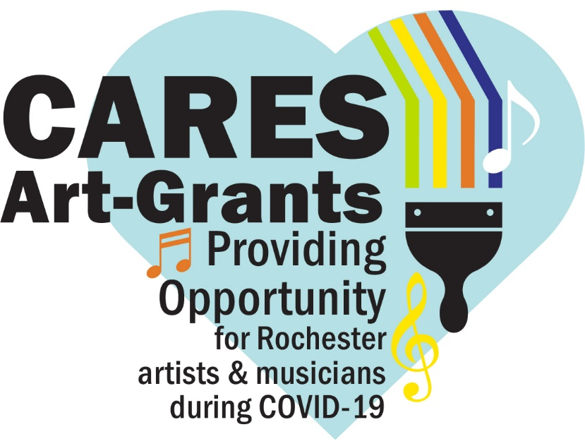
Chalk The Walk:
Be The Healing
Poet Application Form

On Saturday, August 15, we’re inviting you to take part in a city-wide poet Chalk the Walk Festival. This will include pavement poetry and sidewalk art done by neighbors, as well as professionals.

The goal is to provide opportunities for artists whose livelihoods have been impacted by the COVID-19 pandemic, and in turn add colorful art throughout Rochester, cultivating joy and positivity.

Funds for the project are from the Coronavirus Aid, Relief, and Economic Security (CARES) funding, originating from the federal government and allocated to the City of Rochester by the State of Minnesota. The CARES federal grant funds are being allocated in Rochester in many different efforts, including allowing our community to provide local artists work who have been affected by COVID-19.

Poet Grant
Opportunity for local poets who are not fully employed due to COVID-19 to create poetry.
- Poets must be 17 years and older to participate and must reside or work in Rochester.
- Grant applications are due Monday, August 10, at 5 pm.
- Applicants will be notified by Wednesday, August 12.
- Poems will be used by artists at pe-determined location for the Chalk the Walk Festival on August 15 (August 16 rain date).
- $100 for accepted poets to be paid upon receipt of completion form.
- Topics themes include health, equity, community, collaboration, and joy.

- Poet contact information:
Name | Phone | Email

2. Address the following questions in 500 words or less:
How has COVID-19 affected your income as a poet?

Rate how COVID-19 has affected your income on a scale of 1-5, 5 being most affected?

Would you like your poem to be judged upon completion? Chance to win a gift card!
Your poem title:
Poem
Would you like your poem to be used by a local artist to incorporate into their chalk mural for the Chalk the Walk event?
OR
Would you like to participate and chalk draw your poem at a designated neighborhood sidewalk location on August. 15th (rain date August 16th)?
Do you have a proposed chalk poem location (not required) or would you like us to pair you with a neighborhood who would like a chalk poem?

3. Name/signature of persons submitting the application:
If awarded, the total scope of work and implementation of the project are under the domain and control of RNeighbors. The City may exercise oversight of the project if related to City-owned facilities or for large projects. I certify that I have the ability to make decisions-of the applying person/group. I reviewed this information, and all information contained herein is accurate.

_____________________ _____________________ _____________________
(print name) (signature) (email)
Please submit the completed application by Monday, August 10, at 5 pm, to rene@RNeighbors.org. Questions – contact René Halasy, rene@RNeighbors.org.

