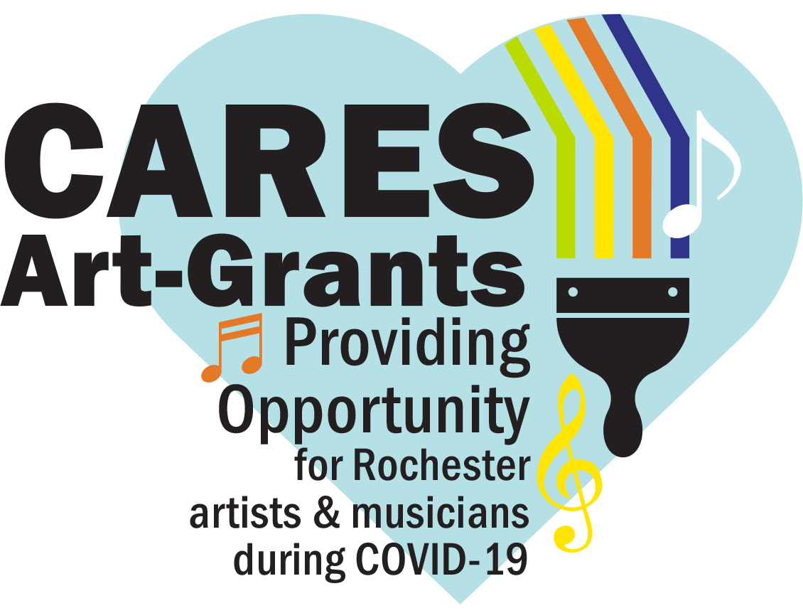
Artist Mural Grant Application

To support the creation of neighborhood-based arts including permanent, outdoor painted murals and music throughout Rochester neighborhoods in the fall of 2020.

The purpose of this program is to provide projects for artists whose livelihoods have been impacted by the COVID-19 pandemic while cultivating joy and positivity throughout the city. Organizers acknowledge that we’re giving artists a short time-frame to complete this application. The program and funding guidelines unfortunately didn’t allow for any additional time.

Grant applications are due September 10, at 5 pm. Applicants will be notified by September 16.

Mural Grant Summary
- Grant Amount: based on square footage of mural
  - 350-500 square ft. = $4,000
  - 200-350 square ft. = $3,000
  - 100-200 square ft. = $1,500
- Mural Locations: should occur in places easily seen by the public throughout neighborhoods
  - Schools and businesses are eligible
  - Any private properties must have owner’s written approval prior to grant approval
- Supply Budget will be provided (in addition to grant payment) and can include artists’ labor, paint, brushes, chalk for gridding, wipes, ladders, scaffolding and bucket truck rental (if needed for height)
  - 350-500 square ft. = $600
  - 200-350 square ft. = $400
  - 100-200 square ft. = $250
- Mural Requirements
  - Encouraged topics include: health, equity, community, collaboration, joy
  - Artwork must be approved before painting begins
  - Mural needs to be completed by November 1, 2020
  - All murals will have a top coat of Sher-Clear 1K Waterborne Acrylic Clear Coat
  - No political statements, profanity, and cannot endorse specific products, businesses etc.
  - Projects that allow neighborhood volunteers to interact or collaborate in some way are preferred, but not required
    - Such as a color by number mural design with youth help painting
    - Listening session, Zoom call, or some other approach to get neighborhood input on theme
    - Social distance best practices must be followed for any mural activities, must align with Minnesota Department of Health Guidance and Governor Walz Executive Orders.
- Artist
  - Minimum Age: 18
  - Must reside or work in Rochester
  - Must be able to prove that employment has been affected by COVID-19
  - Encouraged, but not required to participate in “Tips on How to Write a Successful Grant Application” workshop, on August 26, 6:30-7:30 pm. Local artist, Mary Beth Magyar will lead the Zoom virtual workshop.

Mural Grant Application

Brief Bio/Artist Statement (200 min -500 words maximum)

Need & Qualification Statement
- Is your work as an artist a business?

- If yes, do you qualify as a Veteran, MBE or WBE? (see definition below)

A minority-owned business (MBE) as one in which the majority (at least 51%) of the company is owned and run on a daily basis by a member (or collection of members) of four ethnic or racial groups: African Americans, Asian Americans, Hispanic Americans, and Native Americans.

A Woman-Owned Business Enterprise (WBE) is defined as one that is at least 51% owned, operated and controlled on a daily basis by one or more female American citizens. WBEs are typically certified by a third-party, city, state or federal agency.

- Please describe how COVID-19 has affected your businesses as an artist.

- Rate how COVID-19 has affected your income on a scale of 1-5, 5 being most affected.

- What artistic medium do you typically work in/prefer?

- If we did a Zoom session on “Mural Tips and Lessons Learned” by a local, long-time muralist would you be interested in hearing it? Yes or No

Project Narrative (500 words or less): please describe your proposal, include
- Mural name:
- Location address (if determined):
- Location description:
- Size:
- Vision of mural: encouraged topics include: health, equity, community, collaboration, joy
- How will you plan to complete the mural by the November 1, 2020, deadline?

Neighborhood/Community Involvement
- Are you working with a registered neighborhood association? (not required). If yes, which neighborhood?

- How will you include neighborhood residents in the project planning process?

- Do you plan to encourage neighborhood interaction with your proposed artwork? If yes, how do you propose to maintain social distance best practices as required by Minnesota Department of Health Guidance and Governor Walz Executive Orders.

- Do you have partners supporting and/or collaborating on this effort? If yes, please provide here.

Mural Leadership Team
Name | Phone | Email

Proposed Budget: Please provide a detailed budget in the following table.
- Amount Requested: the dollar amount you are asking for the project. This should include your time and supply budget (detailed below).
  - Grant Amount: based on square footage of mural
    - 350-500 square ft. = $4,000
    - 200-350 square ft. = $3,000
    - 100-200 square ft. = $1,500
  - Supply Budget will be provided (in addition to grant amount detailed above) and can include artists’ labor, paint, brushes, chalk for gridding, wipes, ladders, scaffolding and bucket truck rental (if needed for height).
    - Supplies will be secured through local businesses contract with RNeighbors
    - All murals will have a top coat of Sher-Clear 1K Waterborne Acrylic Clear Coat
      - 350-500 square ft. = $600
      - 200-350 square ft. = $400
      - 100-200 square ft. = $250

Item | Source | Amount Requested
TOTAL

(add rows as needed)

Attach the Following: electronically as jpg or pdf to rene@RNeighbors.org.

- Mural design (8½” X 11”)
- Project location map
- Proposed project/site photos (digital copies are preferred and can be attached to the application or emailed to rene@RNeighbors.org with project title as the subject).
- 5 Minimum -10 maximum photos of past work. Murals preferred, but other mediums are acceptable. Give us a sample of your talent.
- If applicable, any letters of support and/or assistance from Neighborhood Association President. An email is adequate.

Name/signature of person submitting the application:
If awarded, the total scope of work and implementation of the project are under the domain and control of the artist. The City may exercise oversight of the project if related to City-owned facilities. I certify that all information contained herein is accurate.

_____________________________ __________________________ ________________________
(print name) (signature) (email)

Please submit the completed application by Thursday, September 10, 2020, at 5 pm, to rene@RNeighbors.org.

