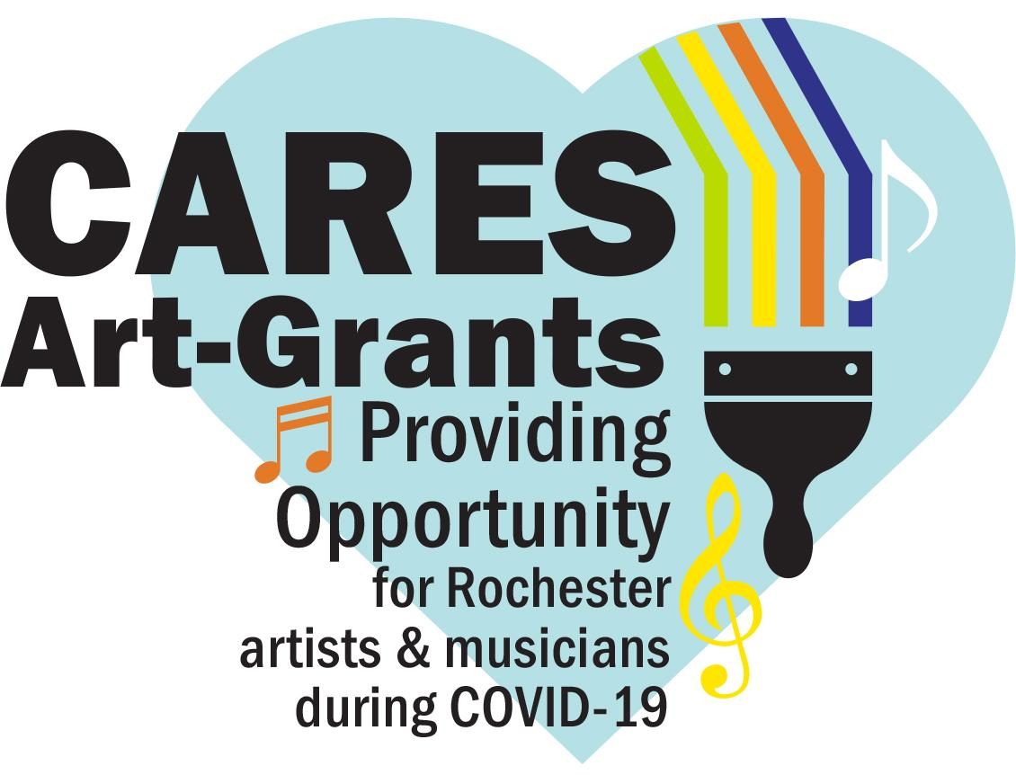

**2020 CARES Art Mural Agreement**

**Mural Artist**

________________________________________________

(name)

**Mural Location** **Business/Organization**

________________________________________________

(mural location)

The Mural Artist and Mural Location agree to the following:

1. The CARES Art Mural Artist agrees to:

* Design, prepare the wall, paint, and seal with a clear coat the mural at this location following the approved sketch.
* Responsibility for bringing all materials necessary to complete the work on site. In all cases, completion shall occur before November 1, 2020.
* Receive payment from RNeighbors once the mural is finished and a Grant Completion form is completed.

1. The Location Business/Organization agrees to having a CARES Art Mural painted on a predetermined outside wall and agree to:

* Upon completion the art becomes the property of the location of the mural.
* Pledge to have it visible for at least a year after completion.
* Understand the business/organizations is donating use of space for the mural and not receiving any funds for the art.

1. The City and RNeighbors may use images of the completed art, as well as images taken of the artist in mural creation for non-commercial, educational and promotional purposes in print or electronically.
2. This Agreement does not imply an employer-employee relationship between the City, County, or RNeighbors and the Artist.
3. This agreement shall be governed by and construed under the laws of the State of Minnesota.
4. This agreement constitutes the entire agreement between the parties. No waiver, consent, modification, or change of the terms of this agreement shall bind either party unless in writing and signed by both parties. Such waiver, consent, modification or change, if made, shall be effective only in the specific instance and for the specific purpose given. There are no understandings, agreements, or representations, oral or written, not specified herein regarding this agreement.
5. The Artist shall save and hold harmless the City of Rochester, the Park Department, Olmsted County, and RNeighbors, its officers, agents, employees, and members, from all claims, suits, or actions of whatsoever nature resulting from or arising out of the activities of the Artist or its subcontractors, agents, or employees under this agreement.

THIS AGREEMENT, made this ____ day of _________, 2020 (“**Effective Date**”), for 1 year.

**Artist:**  
_________________________________ ___________________________________  
 Print name Signature

**Mural Location business/organization representative:**

_________________________________ ___________________________________  
 Print name Signature