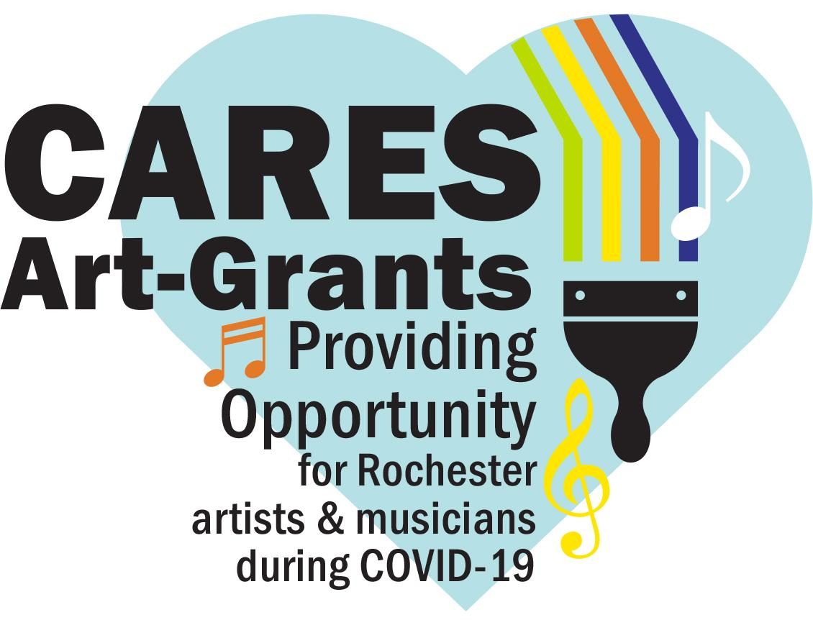
CARES Music and Performance Art Grant Application

This grant opportunity gives musicians and performance artists work opportunities to showcase their talents in public spaces where people can safely enjoy. Neighborhoods and not-for-profit organizations can work with musicians and performers to schedule a socially-distanced performance, spreading joy and positivity in this uncertain time of COVID-19.

Grant Guidelines
- Grants pay performers directly up to $500 in costs to support a neighborhood-based or virtual performance.
- All Rochester-based musicians, performers, neighborhoods, and nonprofits are eligible to apply. Do not need to be a part of a registered neighborhood association.
- There can be no charge for audience members.
- We encourage you to collaborate with a musician or performance artist, giving work to those who need it. If you need contacts please see the attached local performers list for a start.
- Proper social distancing is required for grants. Activities must align with the Minnesota Department of Health Guidance and Governor Walz Executive Orders.

- Grant Ideas
        - Feature a Rochester band in your driveway
        - Hire a local DJ for a neighborhood dance party (everyone dances in their own lawn)
        - Contract with local performing artists to do an interactive poetry-slam

- Project must be completed by November 1, including a short grant summary.
- Performers will be paid by RNeighbors with a check once an invoice is received of performance.
- Grant applications will be reviewed as they come in. Applicants will be notified promptly to allow for quick implementation.

We look forward to helping you make your ideas reality for cultivating positivity. Questions? Contact René Halasy, rene@RNeighbors.org.

Please keep in mind at this time many are out of work and in survival mode. If you have neighbors in need of essential supplies, food, or other services please connect them with this community resource for local organizations that can assist. https://c2cmn.com/covid19

Music and Performing-Arts Grant Application

- Name of applicant (neighborhood representative, performer, or nonprofit):

- Name of musician or performance artist(s):

- Performer is based in Rochester. Yes No based in ____________________________.

- How has COVID-19 affected the performer(s) income?

- Location for performance (address, park, neighborhood, etc.):

- Activity name (Music in the Park, Driveway Tunes, Poetry in the cul-de-sac, etc.):

- Activity description. How will this event enhance/benefit the neighborhood and foster a sense of community?

- What steps will you take to engage the community (neighborhood or virtual group) to enjoy this event?

- Amount requested (up to $500): ___________
A completed grant summary form and an invoice is needed for payment of performers.

- Names and contact information of persons submitting the application:
If awarded, the total scope of work and implementation of the activity are under the domain and control of the applicant. We certify that the decision-making body of the applying group has discussed this information, and information contained herein is accurate.

_____________________ _____________________ _____________________
(print name) (cell number) (email)

_____________________ _____________________ _____________________
(print name) (cell number) (email)

Please submit the completed application by Tuesday, October 20, 2020, at 5 pm, to rene@RNeighbors.org. Applications will be reviewed as submitted.

Local Performing Artist List
Here is a small collection of local, family friendly acts, many of which do not need electricity for their performances. This is not a definitive list but a starting point of reference.

Poetry/Spoken Word
- Dominique Jones
xziring@yahoo.com

DJs
- LaideeP
laideepbookings@gmail.com

- DJ Supafly - Ivan Avalos
dj-supafly.com
507-218-7863

- Tony Fuel Music
https://linktr.ee/tonyfuelmusic

Bands
- Pat Egan
Pategansongs@gmail.com
(507) 398-7465

- My Grandma’s Cardigan
612-670-5364

- Raven’s Fire (Celtic)
theravensfirebrand.com

- Luke Hendrickson
Lukehendricksonmusic.com
507-316-7995

- Jeremy Jewell
jackpotjewell.com

- Dino & Vino (Facebook)
dinoandvinomusic@gmail.com

- Root River Jam
rootriverjam.com
507-273-1710

- The D’Sievers (Jazz)
siev0044@umn.edu

- Amanda Jay
507-250-0965
Music@homesteadumc.org
FB Messenger

- Ben Gateno (classic guitar)
bengateno.com

- Josiah Smith
Facebook

- LaSonya Natividad
Facebook

- Good Morning Bedlam Isaak@goodmorningbedlam.com

