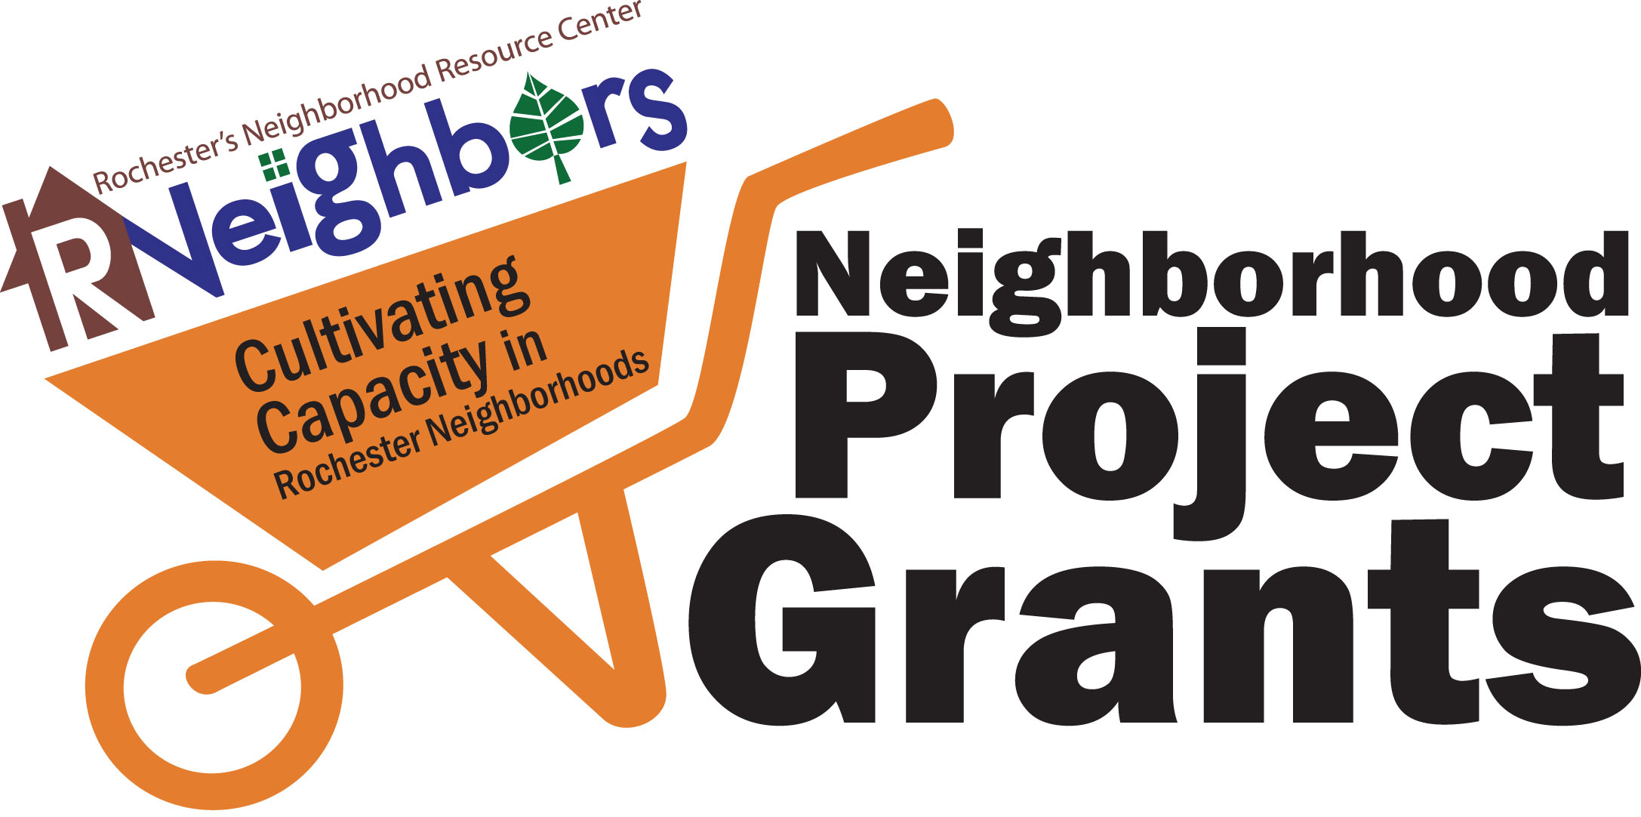
RNeighbors 2021 Neighborhood Grant Application Form

- Project title:

- Neighborhood association name:

- Neighborhood association board members:

________________________ ________________________ ________________________

________________________ ________________________ ________________________

- Core leadership team on the project:
Name | Phone | Email
(add rows as needed)

- Project Narrative
5.1. Brief project description:

  - Detailed budget (include in-kind donations):
In-Kind examples include: donated supplies, reduced professional rates, and volunteer time at a value of $25.43 per hour. Volunteer hours are important to keep track of throughout your project. In this estimate please include all planning meetings, grant writing, work sessions and neighborhood meetings when project is reviewed. Please provide a financial estimate.
Example: Donated supplies $450 and volunteer time (70 hours x $25.43) $1,780.10 total of $2,230.10

Item | Source | In-Kind Amount | Cash Amount
Total Funds Requested

Total in Match

(add rows as needed)

5.3. Address the following questions in 500 words or less:
- Describe how this project will enhance/benefit the neighborhood and foster a sense of community?
- How does the project include opportunities to involve multiple neighbors in shaping and carrying out the project?
- How have/will neighborhood residents been included in the project planning process?
- What partners are supporting and/or collaborating on this effort?
- How will your neighborhood association sustain the project beyond the initial grant year?

- Attach the following:

- Letters of support and/or assistance from Neighborhood Association President and any in-kind participants. An email is adequate.
- Project location map (8½” X 11”).
- A site design, if applicable (8½” X 11”) for projects like murals, gardens or signage.
- Proposed project/site photos (digital copies are preferred and can be attached to the application or emailed to rene@RNeighbors.org with project title as the subject).

- Name/signature of persons submitting the application:
If awarded, the total scope of work and implementation of the project are under the domain and control of the neighborhood association. The City may exercise oversight of the project if related to City-owned facilities or for large projects. We certify that the decision-making body of the applying group has discussed this information, and all information contained herein is accurate.

_____________________ _____________________ _____________________
(print name) (signature) (email)

_____________________ _____________________ _____________________
(print name) (signature) (email)

_____________________ _____________________ _____________________
(print name) (signature) (email)

Please submit the completed application by Wednesday, July 14, 2021, at 5 pm, to rene@RNeighbors.org.
Questions – contact René Halasy, rene@RNeighbors.org.

