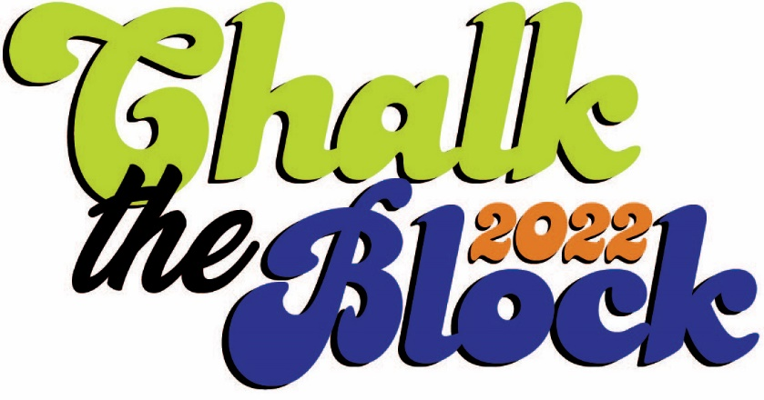
Artist Application Form

Application Deadline
Friday, July 15, 5 pm

On Saturday, July 23, we’re inviting you to take part in a city-wide Chalk the Walk Festival. This will include pavement poetry and sidewalk art done by neighbors, as well as professionals.

Chalk the Walk Grant
Opportunity for local artists to create sidewalk chalk murals for payment in a Rochester, Minnesota, neighborhood.
- Applicant must be 17 years and older to participate and must reside or work in Rochester.
- Grant applications are due Friday, July 15, at 5 pm, and should be emailed to rene@RNeighbors.org.
- Applicants will be notified by Sunday, July 17.
- Work to be completed on the pre-determined location for the Chalk the Walk Festival by July 23 (July 24 rain date).
- $300 for accepted sidewalk chalk murals to be paid upon receipt of completion form.
- Supplies will be purchased by RNeighbors and made available for artists at the Development Services & Infrastructure Center (DSIC), 4001 West River Pkwy NW, including: assorted colors of soft pastels, sponges, baby wipes, and fixative.
- Theme: "Creating Memorable Connections!"
- We are working with local poets and will provide you a choice of two poems. You can choose one to incorporate into your artwork.
- Sidewalk surface area: 4 foot x 4 foot, or 16 square foot total.

- Artist contact information, including team involved (if applicable):
Name | Phone | Email

- Name of chalk mural:

- Please give us a brief description of your chalk mural. Mural topic to help inspire you: "Creating Memorable Connections!"

4. Do you have a proposed chalk mural location (not required)? We will be positioning mural locations across the city.
5. Submit 4 samples of past work. Submission of work samples in any medium. Insert photos below or attach to email submission.
6. Submit a completed W-9.

7. Name/signature of persons submitting the application:
If awarded, the total scope of work and implementation of the project are under the domain and control of RNeighbors. I certify that I have the ability to make decisions-of the applying person/group. I reviewed this information, and all information contained herein is accurate.

_____________________ _____________________ _____________________
(print name) (signature) (email)
Please submit the completed application by Friday, July 15, at 5 pm, to rene@RNeighbors.org. Questions – contact René Halasy, rene@RNeighbors.org.

