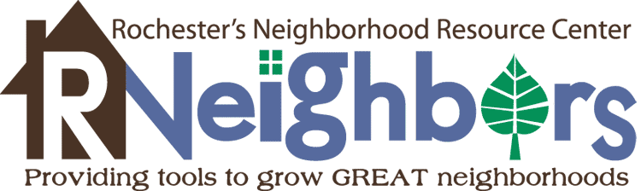

**Neighborhood Training Grant Application**

Each year RNeighbors has attended the Neighborhoods USA (NUSA) Conference we have come back energized about neighborhood organizing and full of successful ideas from other cities. The Council on Neighborhoods, the Neighborhood Toolkit, and the Neighborhood Project Grants are just a few of these projects we’ve implemented in Rochester. Now, thanks to funding from the City Council, we’d like to send some neighborhood leaders to this valuable experience. Here is the [conference website](http://www.intheneighborhood.org/2017-nusa-conference/) and attached is the schedule.

If your application is selected, this grant award is $500 to go towards attendance to the NUSA Conference. The 2017 conference will be held in Omaha, Nebraska, Thursday, May 25 and Friday, May 26. In past years (it is not yet posted for 2017) the conference registration has been $200. The remaining $300 would go towards hotel and food, as determined by you. Registration would be paid through RNeighbors and hotel and food costs would be reimbursed. There may be possibility of car-pooling to the conference, details to be decided at a later date. In June the RNeighbors Board would like to hear a short summary about your NUSA experience and what you brought home to put to work in your neighborhood.

1. **Name:**
2. **Neighborhood association name:**
3. **Why would you like to attend the NUSA Conference? Convince us to send you! (500 words or less)**
4. **Please attach a letter of support from either your neighborhood association or another neighborhood partner.**
5. **If selected by the Grant Committee I will attend the 2017 Neighborhoods USA Conference in Omaha, Nebraska, on Thursday, May 25- Friday, May 26 (check the box and sign). ⌂ Yes**

**_____________________ _____________________ _____________________**

**(print name) (signature) (email)**

Please submit the completed application by **Wednesday, March 15, 2017, at 5 pm, to** [**rene@RNeighbors.org**](mailto:rene@RNeighbors.org)**.**

Questions – contact René Lafflam, [rene@RNeighbors.org](mailto:rene@RNeighbors.org).